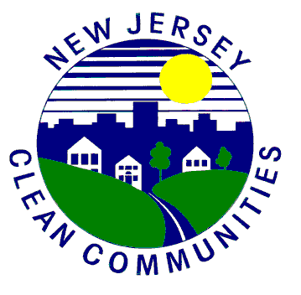
(Your County/Town) Clean Communities
Clean Communities is a Statewide Litter Abatement Program
Dear Presenters-
(County/Town) is sponsoring your education program utilizing Clean Communities Grant funds. Therefore, it is important to us that the audience learn about the harmful effects of litter as well as anti-littering behaviors. Thank you for in advance for agreeing to incorporate the following litter abatement information in your upcoming Clean Communities presentation(s).
- It is very important for the audience to understand the meaning of the word LITTER.
What is litter? Litter is misplaced trash.

- It is also very important to give examples and make the audience understand what they can do to prevent litter and change the attitudes of those who litter.

Examples of litter: plastic bags, candy wrappers, gum, bottles, cans, cups/straws, balloons, cigarettes and any other man-made item that is on the ground (misplaced, not in a container).
- PLEASE use trash and recycling receptacles in order to prevent litter.
- PLEASE cover containers to prevent accidental littering.
- Litter is harmful to the environment, animals and people.
- Never release balloons outside as they end up in trees and waterways and are harmful to animals, fish and birds!
- Storm drains lead to waterways. Roadway litter goes down storm drains and ends up in a river, pond, lake or the ocean, which causes pollution and harms marine life.

Please give a strong message at the conclusion of your presentation:
“Thank you for doing your part by preventing litter and making (County/Town) litter free!”
If you have any questions, please call (your name), Clean Communities Coordinator, 973-285-8393. We are sponsoring your program, thanks!

