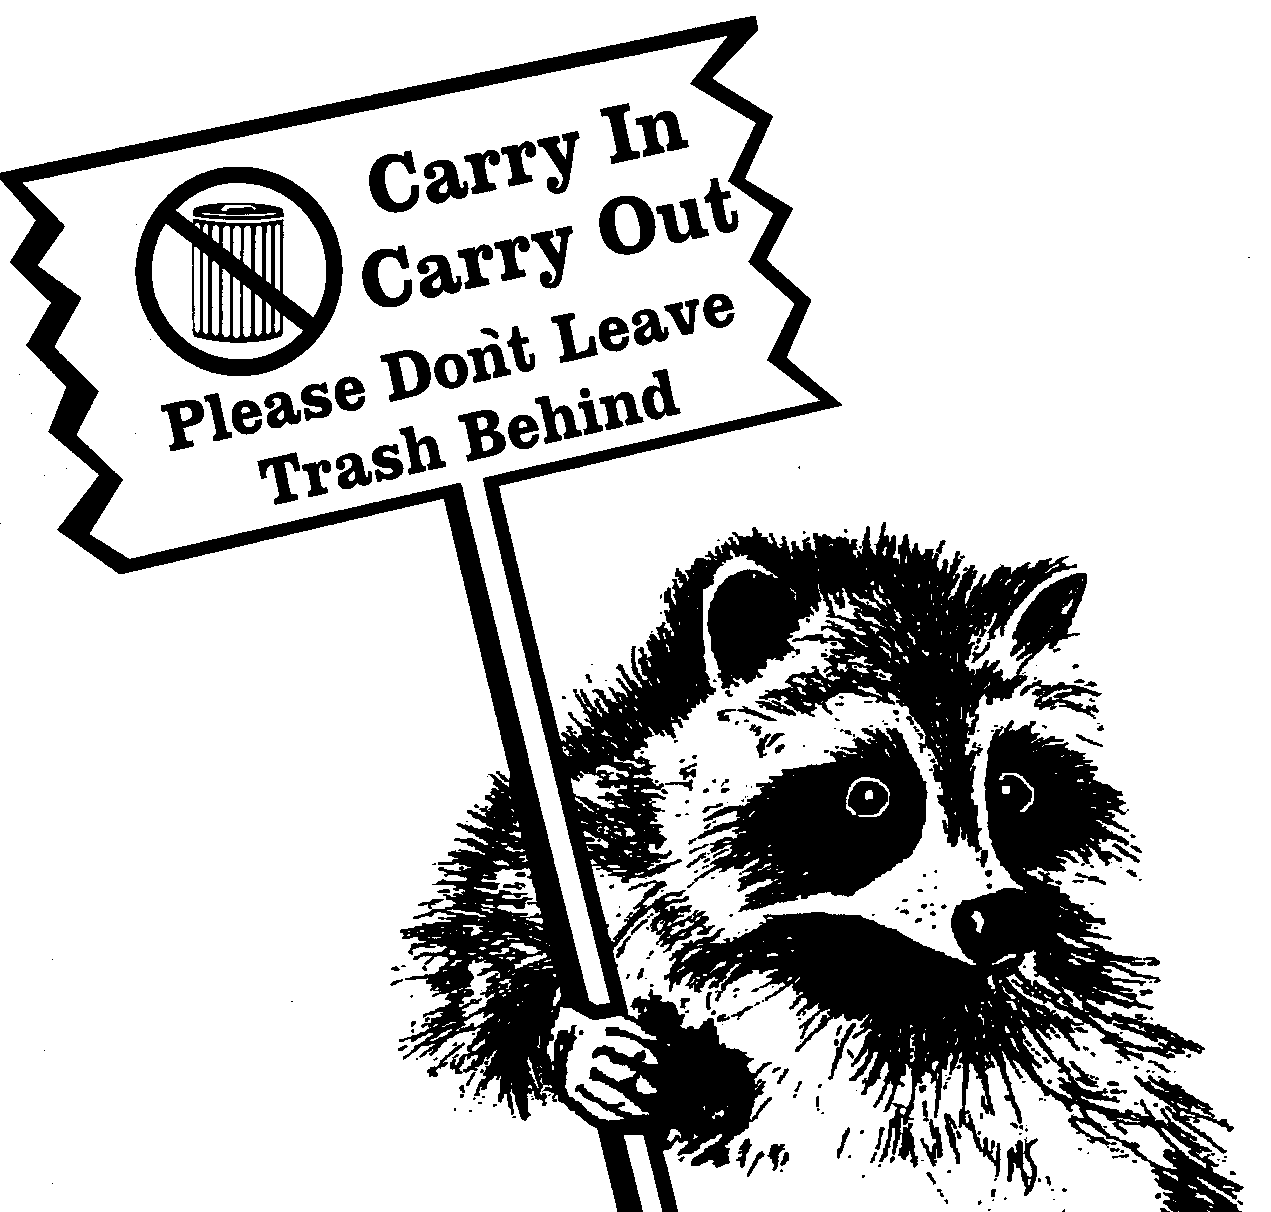
How can I help? Take your trash home with you. Use the brown paper bags located at the entrance to beaches and hiking trails throughout the Sandy Hook.
Please Help Protect
Your Park

Take Your Trash Home With You

Thanks For Your Cooperation

Why should I do this? This will reduce the trash left in the marine environment and better preserve it for future generations to enjoy.

What else can I do? Reduce what you bring with you to the park.
Take re-usable dishes, cups and utensils and then take them home.

The success of Carry In/Carry Out depends on our visitors.

Thank you for helping to keep Sandy Hook clean.

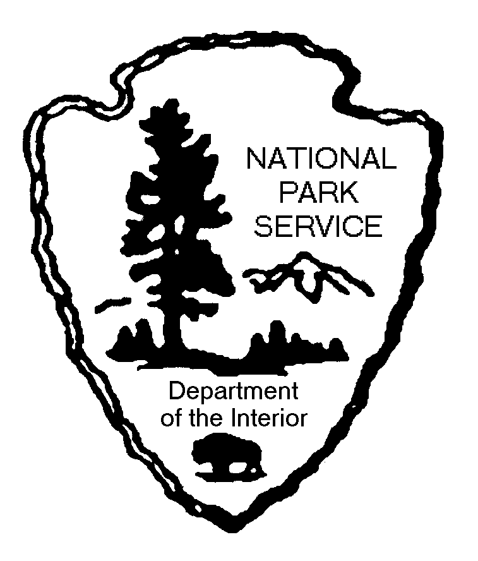

For more information, contact: Sandy Hook
Gateway National Recreation Area
P.O. Box 530
Fort Hancock, NJ 07732 732-872-5970
web site: www.nps.gov/gate

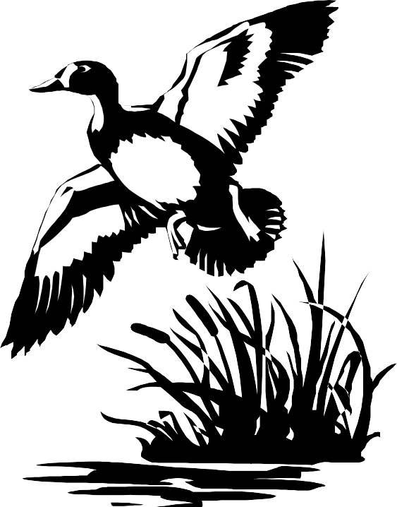
Carry In/Carry Out:
Carry In/Carry Out is designed to reduce the amount of trash on Sandy Hook.

Park visitors are responsible for taking their trash home with them when they leave.

Eliminates unsightly trash on the beach.

Prevents the unpleasant odor associated with discarded trash.

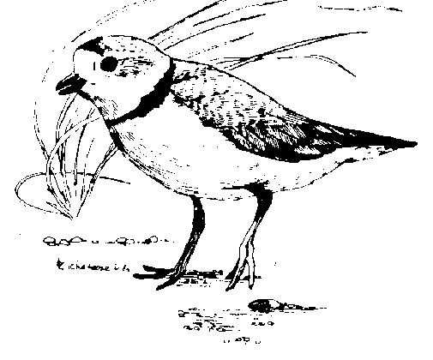
Reduces plastics in the marine environment.
Carry in/Carry Out is a way for visitors to help preserve and protect Sandy Hook’s natural resources and help maintain a clean marine environment.

Helps park wildlife by reducing their dependency on trash as a food source.

